About Page = about.html

The User Guide For The About Page Simply Click On The About In Navbar Then Page Of About Will Open.

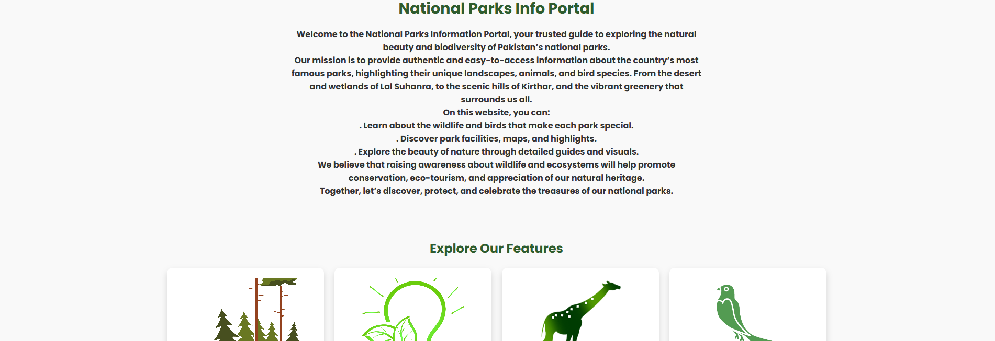

The Home Page Section In Which We Can Directly Explore The From Cards 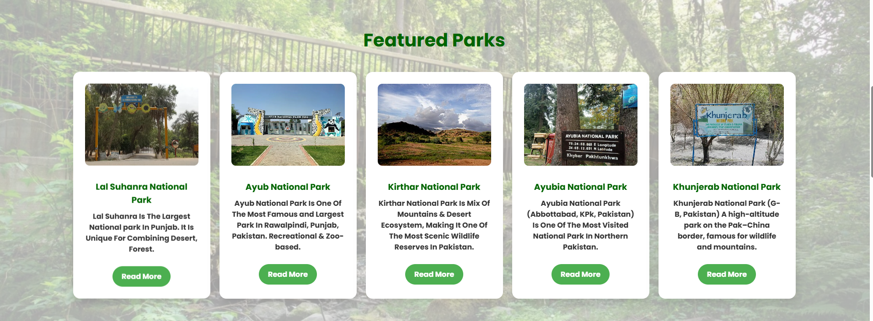

Explore The Parks From Here & Get Information About The Parks Its Location , Facilities , Animals , Birds & History Of Park